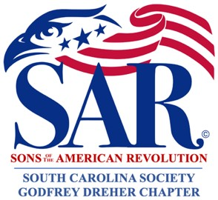

Meeting Minutes for: October 14, 2024

Time: 6:00 pm - Supper 7:00 pm - Meeting

Location: Lizard’s Thicket Restaurant

4616 Augusta Road, Lexington, SC 29073

1. Meeting Called to Order - President McLeod
2. Invocation – Steve Corley
3. Pledges – Sam Padgett, Commander of Colors
   1. Pledge of Allegiance
   2. Pledge to the Flag of South Carolina
   3. SAR Pledge
   4. The American Creed
4. Introduction of Guests – President McLeod  
   --Doug Doster, SCSSAR Past President and Signer of the Chapter’s Charter in 2009  
   --Scott Bruton, SCSSAR Color Guard Commander, and his wife  
   --Ted Walker, SCSSAR Past President, and his wife  
   Chapter members and others present introduced themselves.
5. Celebration of 15th Anniversary of the Godfrey Dreher Chapter formed in 2009

Past presidents, charter members and current President McLeod shared a wealth of information about the history and evolution of the Chapter over the past 15 years. For the first time in its history, the Chapter now has over 50 active members. Fritz Gladfelter, SCSAR Past Treasurer, and SCSAR Past Presidents Don Simmons, Gary Blanpied, Woody Carothers and Bill Wilson gave very informative and inspirational presentations. Two of the Chapter’s early presidents could not physically attend the meeting, but they provided messages which were shared with the group. Carl Epps read a message from the Chapter’s 1st President, Hampton Fuller, and Mike Gillis read a message from Past President Wayne Roberts. (See Addenda to the Minutes for some of their remarks.)  
  
Doug Doster, Past President of the SC State SAR and Signer of the Chapter’s Charter in 2009, commended the Chapter for being a role model for other chapters to follow as “Godfrey Dreher Chapter does it right.” It has a good group of people which is reflective of Lexington County, and he wished the Chapter continued growth and success in the future.  
  
Ted Walker, Past President of the SC State SAR, recognized the leadership of the Godfrey Dreher Chapter and thanked them for their many contributions over the years. Not only has the leadership made this Chapter a success, but they have also had a direct bearing on improvements that were made at the State level, especially in the areas of archival of historical records and awards recognizing accomplishments of officers and compatriots. This Chapter is an example of how the SAR and DAR should work together. Ted also passed along praises and congratulations from the current SCSSAR President Sonny Pittman to the Godfrey Dreher Chapter upon its 15th Year Anniversary.  
  
Ted Walker mentioned the following upcoming events:  
--Oct. 19 SCSSAR Board of Governors Meeting in Columbia, SC  
--Oct. 23 American Revolutionary War Living History Day  
 at JET Middle School in Johnston, SC  
--Nov. 2-3 “Cowboy Days” Festival in Aiken, SC  
--Nov. 8-10 Battle of Camden   
--Nov. 23 Battle of Blackstock’s Plantation Commemoration   
--Nov. 23 Battle of Fort Morris at Midway, GA

1. Presentation by Terry Gladfelter with the Granby NSDAR  
   Terry is on the 250 Commission for Lexington County, and they have received approval by Discovery South Carolina for a highway marker that will be located at Friday’s Ferry where George Washington crossed in 1791. This is near the Cayce Museum, down State Road near Riverland Drive. Terry said they have been promised $4,500 for the marker but it won’t quite cover the total cost. The Granby NSDAR wants to know if our Chapter would like to be a part of this project. It will be the end of January 2025 before any decision is made regarding the front and back of the sign. Also, Terry graciously provided the delicious carrot cake tonight in commemoration of Godfrey Dreher Chapter’s 15th Anniversary.
2. New Business – None
3. Old Business  
   At May’s 2024 meeting, Guest Speaker Mike Burgess raised the issue if our chapter could help develop the Godfrey Dreher homestead. Carl Epps reported that Steven Preston contacted him about serving on a committee to help. The following individuals volunteered to serve: President McLeod, Steven Preston, Aric Bruggeworth, Carl Epps and Terry Gladfelter with the Granby NSDAR.
4. Motion to Approve Minutes was seconded and passed by unanimous consent.
5. Officer/Committee Reports
   1. Vice President for Programs - Gary Blanpied   
      In November, Compatriot Aric Bruggeworth will be the guest speaker, and he will give a genealogy presentation on “Finding the Shirt-Tail Men: Repositories and Resources to Use when Researching your Revolutionary War Ancestors.”
   2. Vice President for Technology – James Herritage  
      No report at this time
   3. Treasurer – Bill Wilson spoke on behalf of Norman Smith   
      Remember to get your dues in to Norman within the month. This Chapter and Aiken’s Chapter have always led the state in number of dues paid in full.
   4. Secretary – Carl Epps  
      No report at this time
   5. Registrar – Mike Gillis  
      There are two applications – one is new and one is supplemental. We are still waiting to hear back on approval, but it may be a couple of months.
6. SAR Recessional/Adjournment

*NOTE:   
Any discrepancies in the information contained herein, please let me know immediately.*

Respectfully submitted by:

Carl L. Epps, Jr., Secretary

November 8, 2024

# ADDENDA ATTACHED WHICH ARE HEREBY MADE PART OF THESE MINUTES.

--Meeting Attendee List

--Remarks made by Past Presidents and Charter members

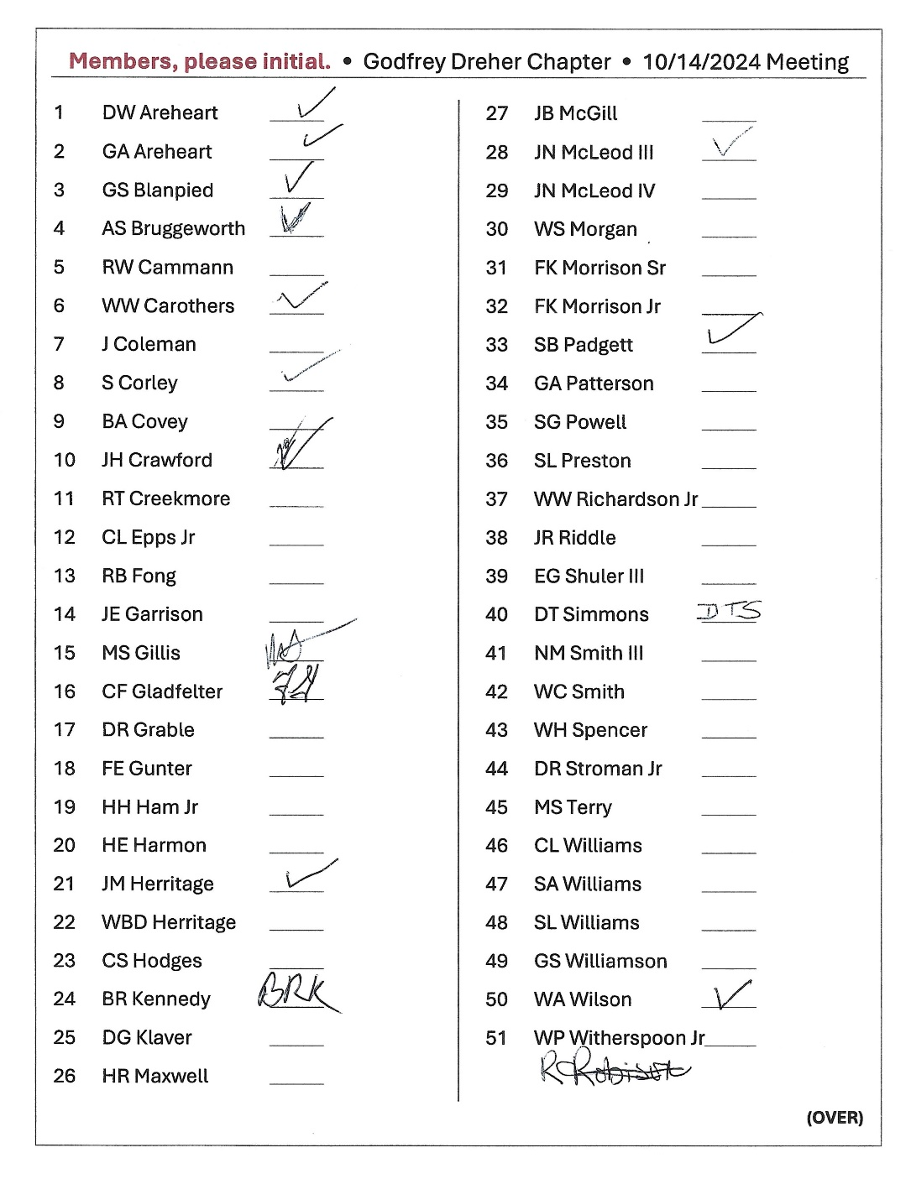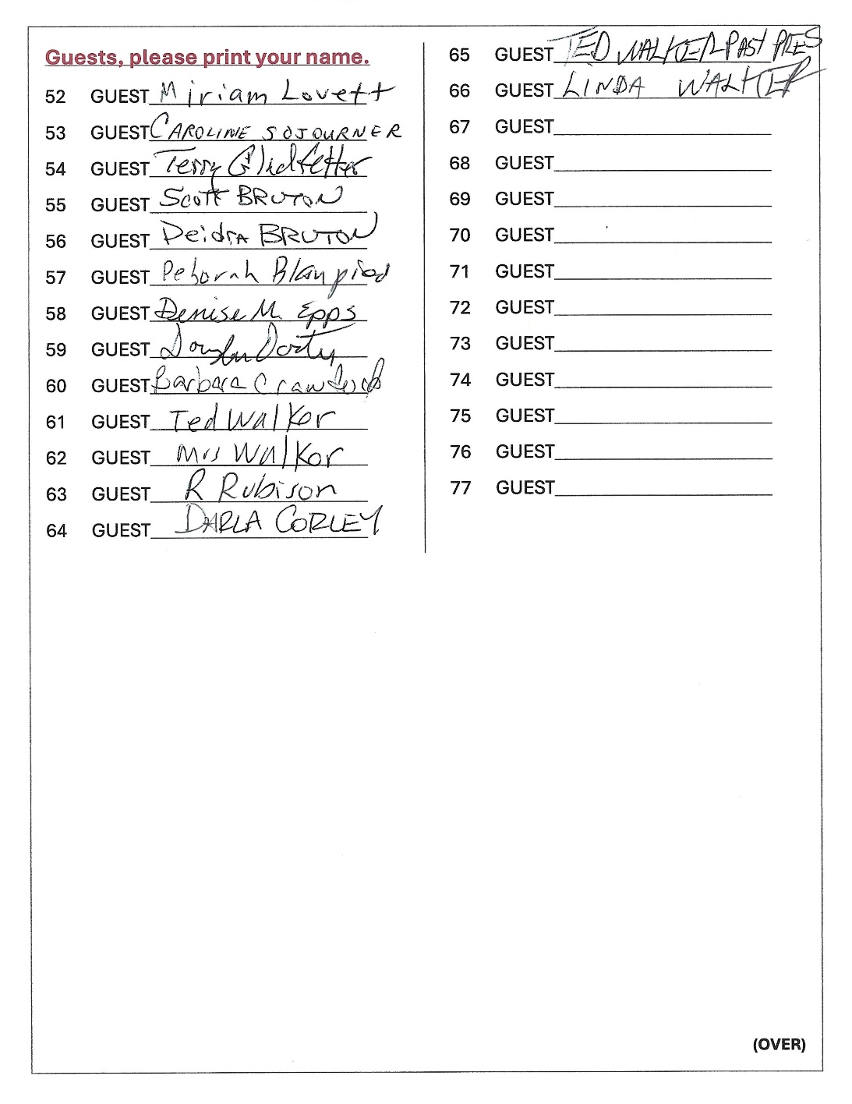

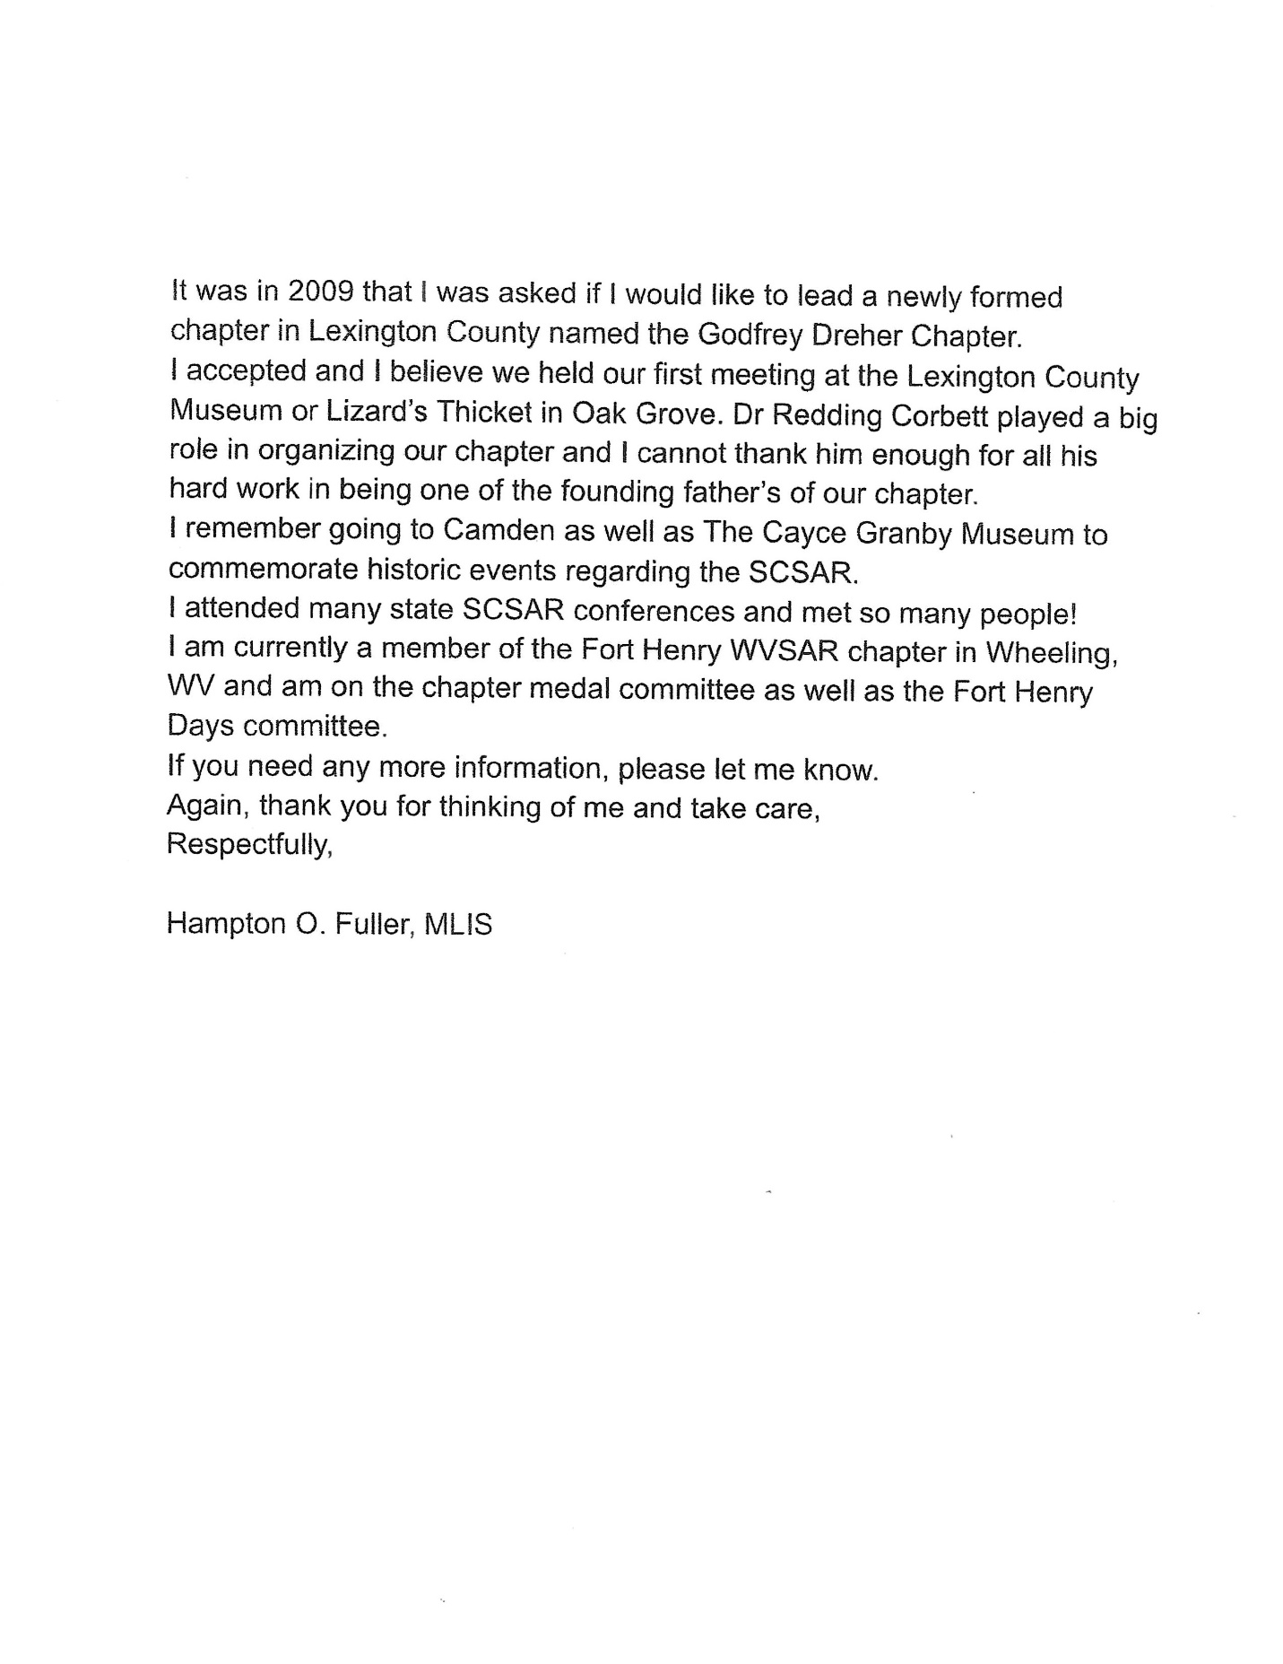

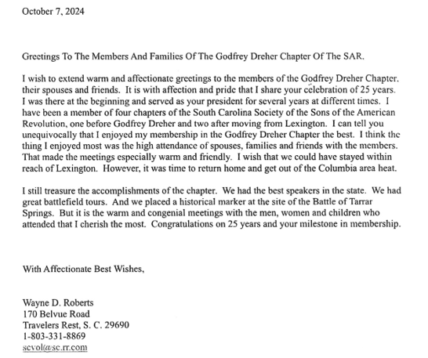

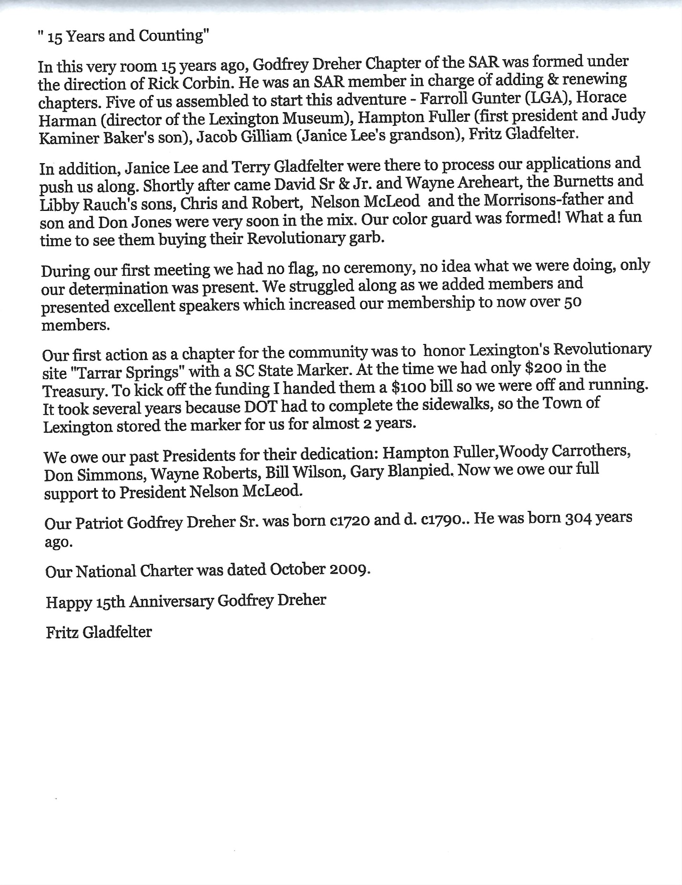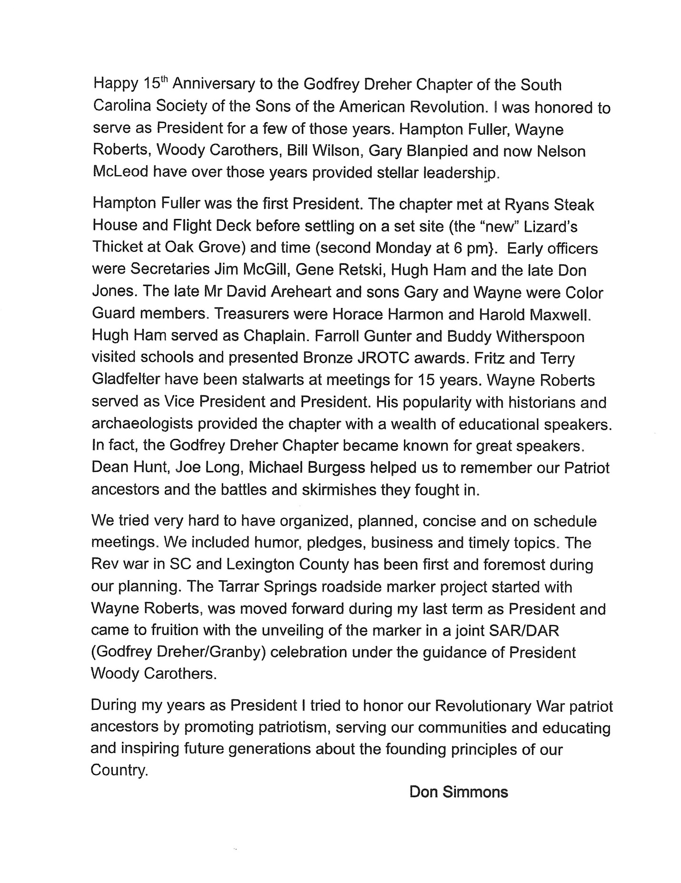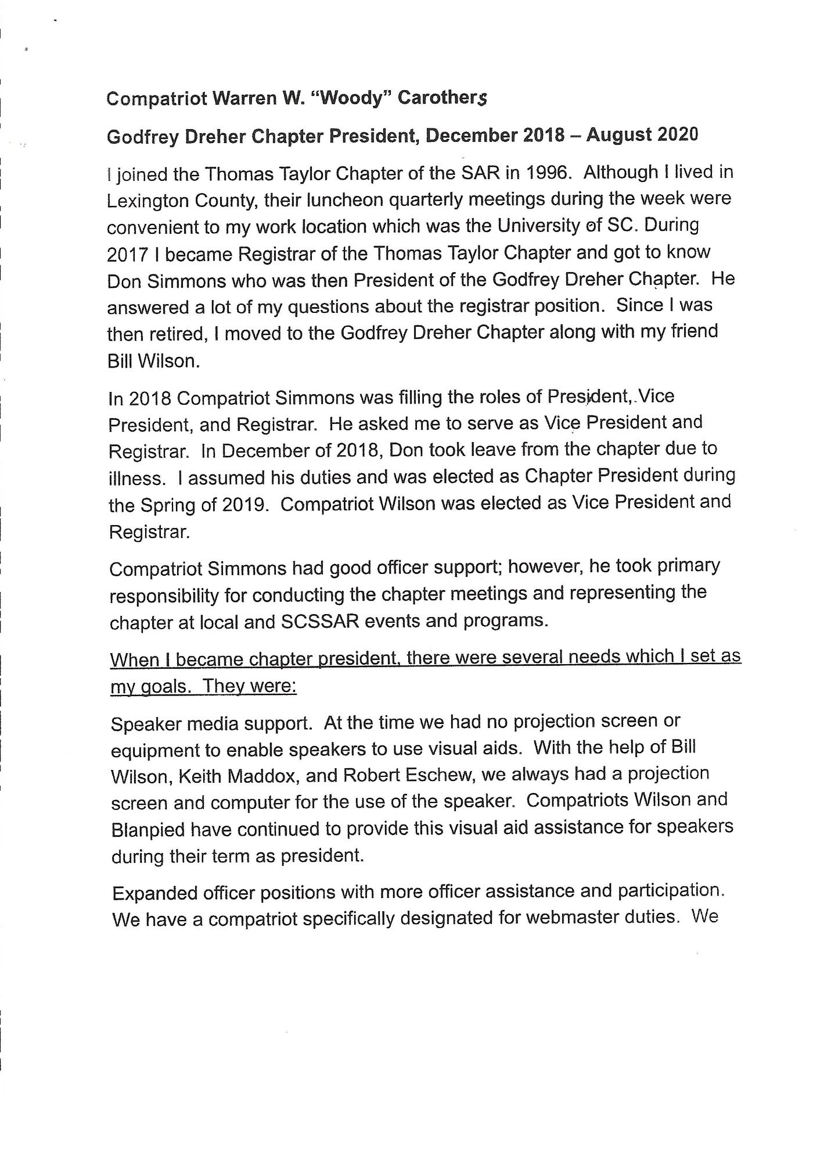

(Carothers Message – 1 of 3)

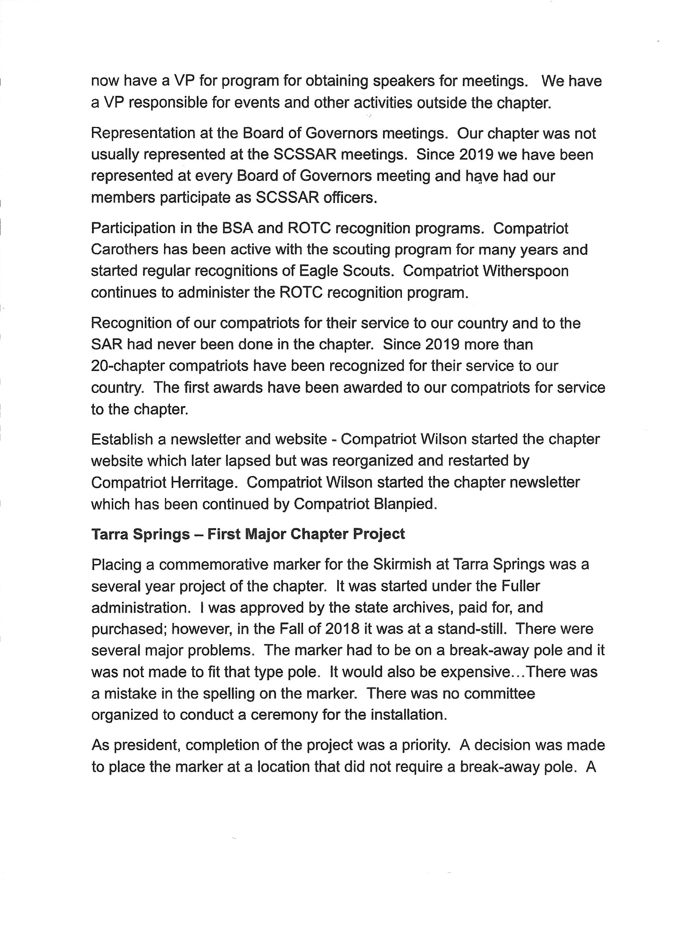

(Carothers Message – 2 of 3)

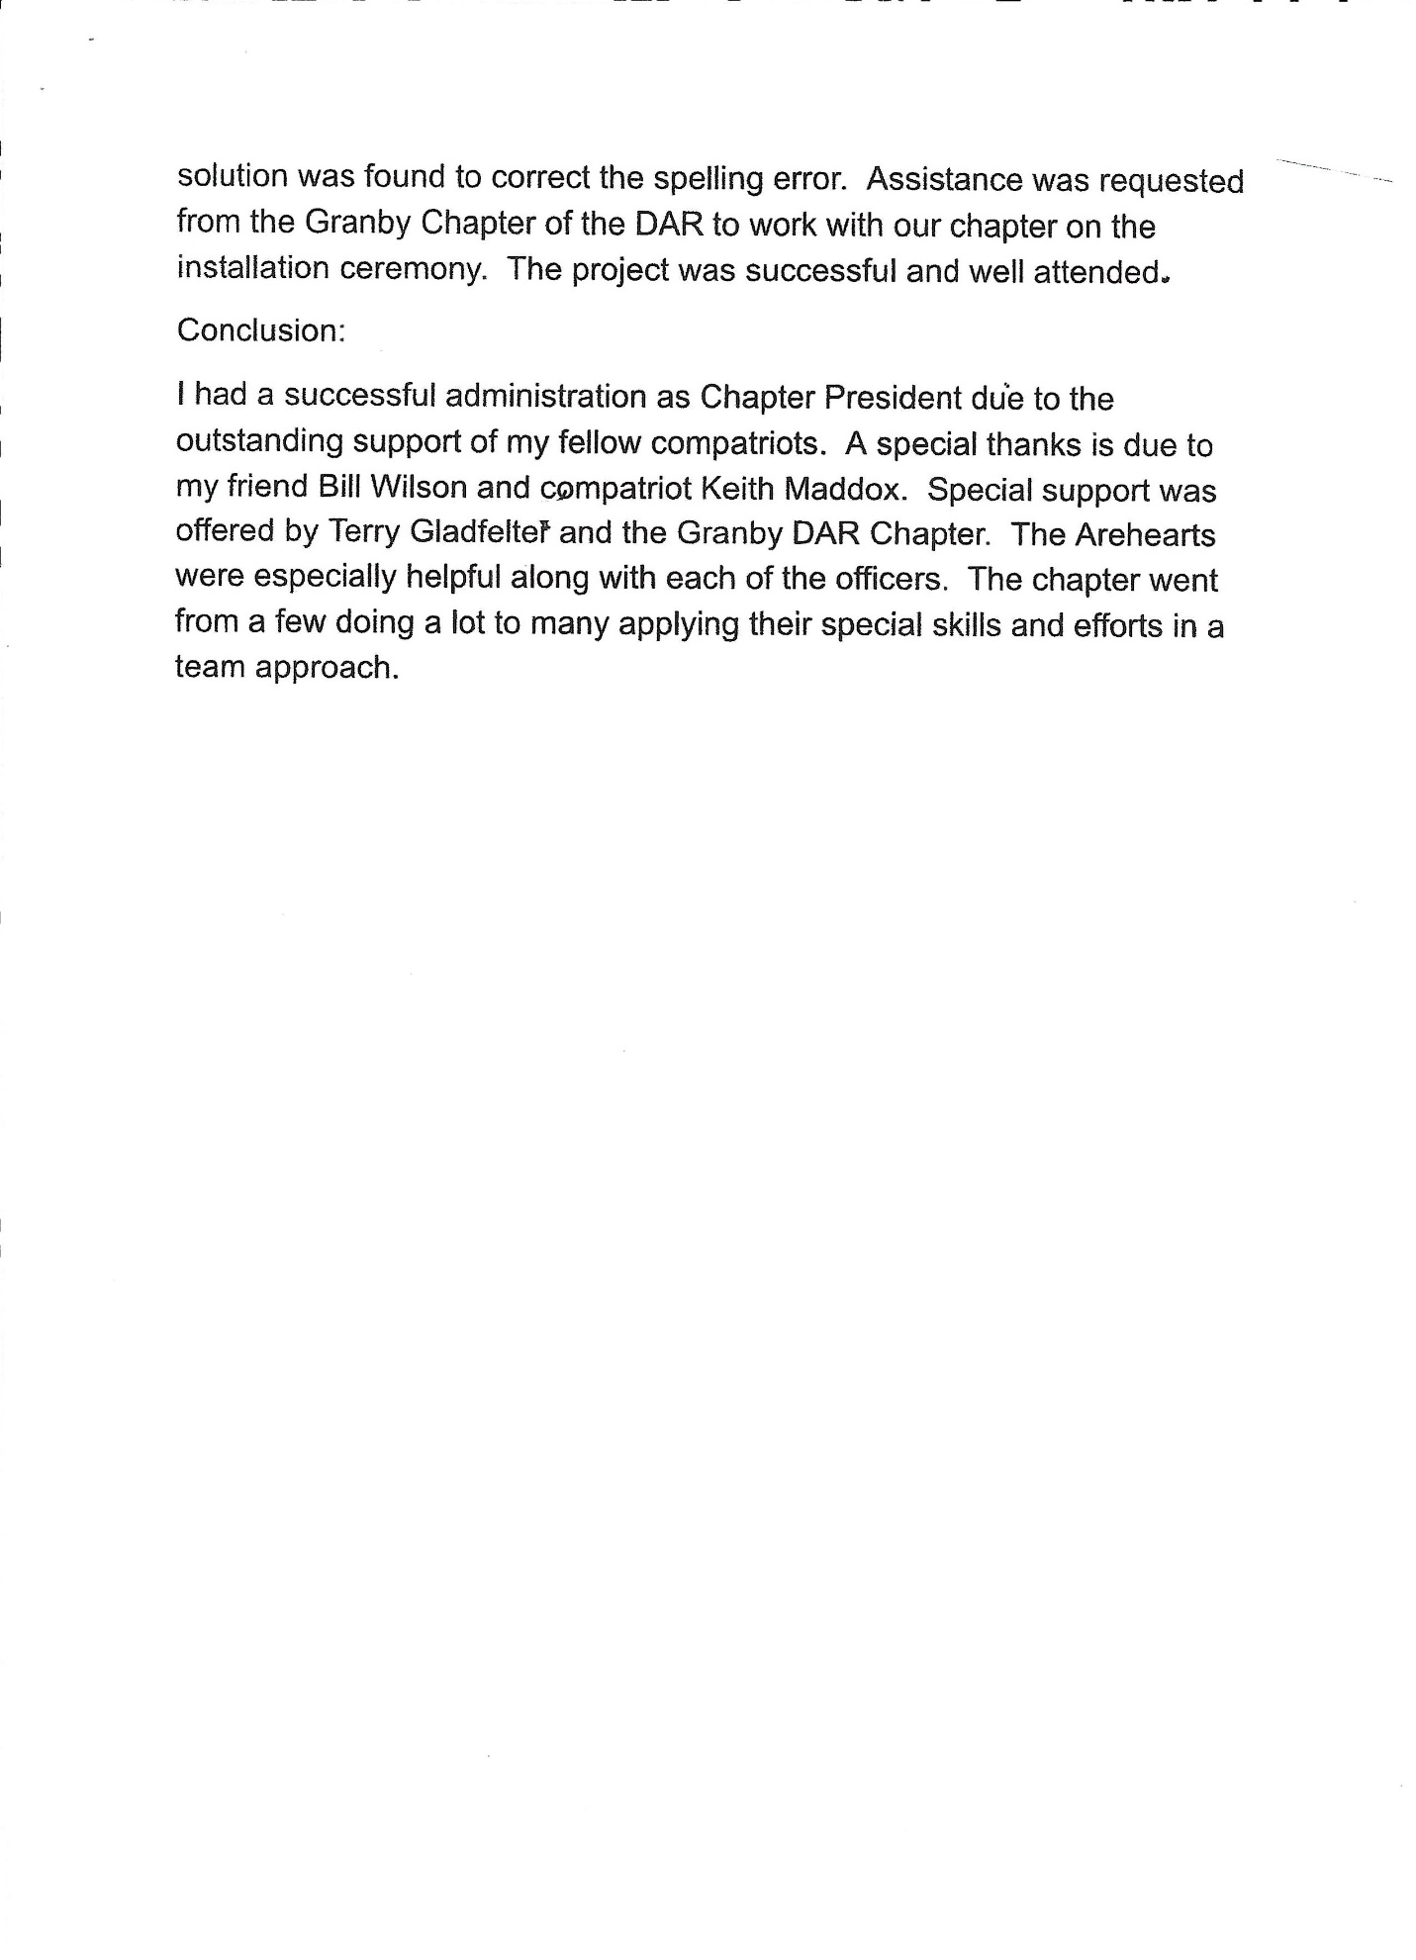

(Carothers Message – 3 of 3)

